# Force and Stress Value Finder

*Omkar Anand Iyer*

*EC23B1075*

**Components used:**

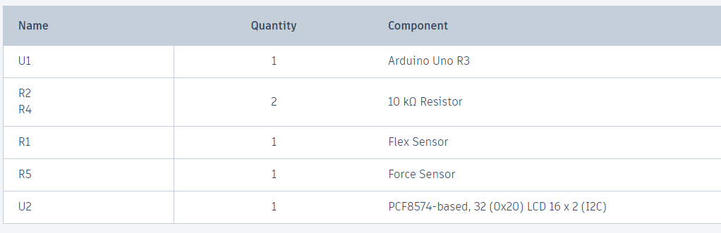

**Working:**

In this project I am using the force sensor to calculate the value of force, assuming that force sensor is a variable resistance which varies linearly with force. To do this I used a voltage divider.

Similar to force sensor I calculated angle using flex sensor and used the formula which I derived for stress.

Stress = sec(angle);

Angle is the angle measured by flex sensor.

**Picture:**

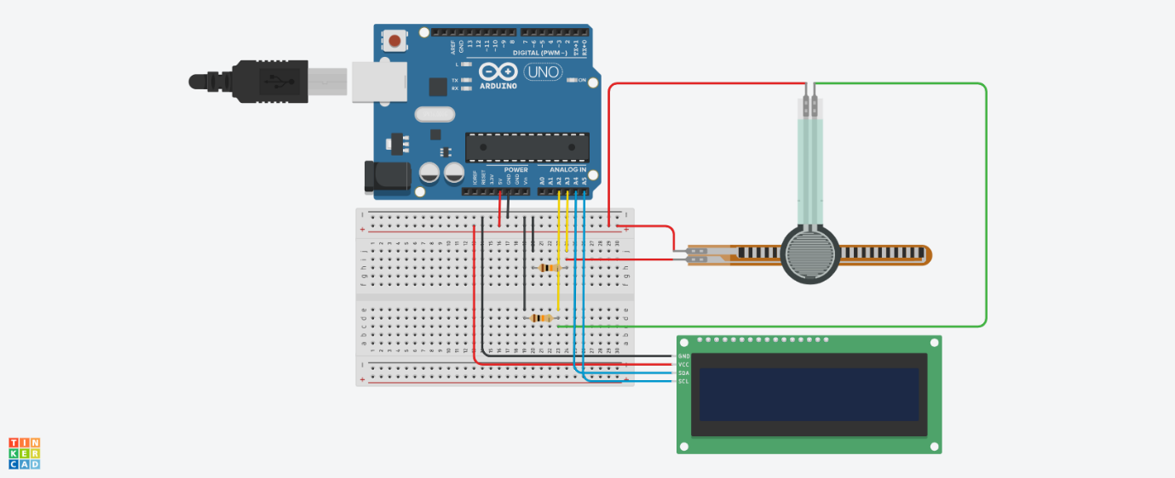

**TinkerCad Link:**  https://www.tinkercad.com/things/jjhTl4vhd7q-flex-and-force-sensor-flex-modulus?sharecode=DBCHRESxoxcoYTGrO2RFUIm4LFZ573gk74iDL91xXiw